My Profile

Yew Zen Jet (Jason)

S3928350

[S3928350@student.rmit.edu.au](mailto:S3928350@student.rmit.edu.au)

[www.com](http://www.com)

+61 412 266 809

Let me introduce myself…

My name is Yew Zen Jet or you could call me Jason. I was born in Malaysia and been travelling to Australia every once in a while, to visit my parents who work in Australia. I love both cats and dogs very equally, so you could say I’m both cat person and dog person. I never really had a specific area of study I’m interested and I never really know the meaning of studying other than getting paid more with higher education qualification.

At the end of 2019, I finished my high school in Malaysia and was totally lost in what I should do next. I spent most of my free time playing PC games with my friends and not planning my future. Due to the Covid-19 outbreak I was not able to go anywhere except staying home and play even more games until I saw some of my high school friends starts to take action in their Uni study. I then start my first study of SACEi (South Australian Certificate of Education) in Taylor College in April 2021. It was more like an extra one year for me to plan my future study since finishing the program will allow me to choose to study between Malaysia and Australia.

Interest in IT

During the mid-term break of the program Taylor and RMIT decided to have three free programs for the SACE student which one of the courses is the Intro to Programming. I decided to join the course to have a better understanding of what exactly programming is about. In the course I learn a little fundamental of Python and I was really enjoying it. It was then I have a clearer pathway where I want to proceed to study in IT programming field. After finish the SACEi in April 2022. I decided to continue my study in RMIT in Australia as my family planned to stay in Australia. I was enrolled in The Bachelor degree of IT.

The main objective of studying this course is that I want to know more about which area of IT I’m interested in whether it’s Web Programming or Software Developer or in Cyber Security. I’m really looking forward to it.

My Ideal Job

The most ideal job for me is to be a backend developer and a hybrid working place would be good to have. I believe my strength in programming is to compile and develop a working app rather than designing UI/UX. This is because based on my current job which is a admin job in Melbourne, I was able to understand the needs of the customer and provide the best solutions and suggestion. I believe that with these skills I’m able to understand what my customers would need if I’m assigned to develop certain app or system.

Based on the website [www.seek.com.au](http://www.seek.com.au) I was able to find some similar job that is close to my ideal job.

<https://www.seek.com.au/job/57948955?type=standout#sol=4b4e45af49d842ec8180e18231ae1ef1b393f624>

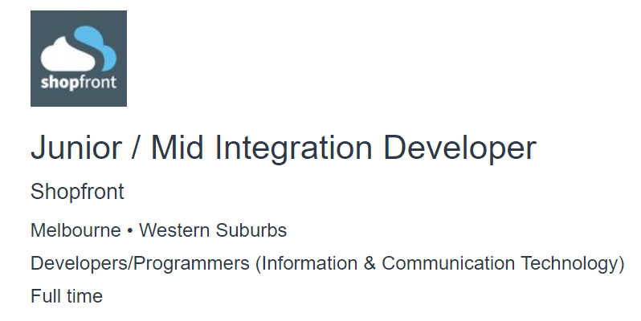

<https://www.seek.com.au/job/57858177?type=standout#sol=6c5cf4f2c858736e9421ca0ac9f28cc6356d4990>



My Personality Profile

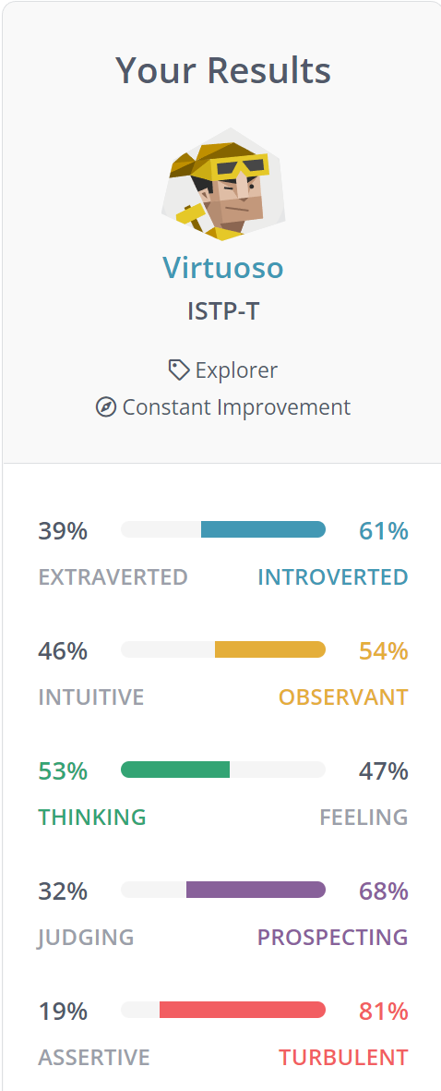

Strengths

**Relaxed**

I’m able to stay quite relaxed. I would live the moment and go with the flow, not worrying too much about the future. This would allow me to always stay positive and enjoy my current life.

**Spontaneous and Rational**

Another strength of my personality is that I could switch mindsets to fit new situations or think from other perspective without much effort. It helps me analyse what, where and why the problem is allowing me to be flexible and versatile.

Weaknesses

**Insensitive**

I tend to use logic in most scenario and even when I try to meet the others halfway with empathy and emotional sensitivity, it rarely seems to quite come out right.

My Future Project Plan

I do not have a really ‘grand’ project in mind but I do want to work on automated machines such as automatic cloth collector and rain detector.